- Procedure with IN Parameter
CREATE PROCEDURE GetFaculty(IN d VARCHAR(10))
BEGIN
SELECT FacNo, FacName, Age
FROM FACULTY
WHERE Dept = d;
END //
DELIMITER ;
CALL GetFaculty('CSE');
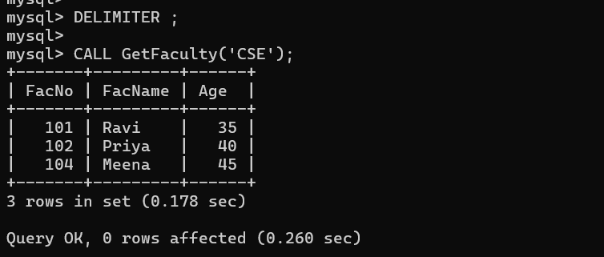

- Procedure with OUT Parameter
CREATE PROCEDURE TotalFaculty(OUT n INT)
BEGIN
SELECT COUNT(*) INTO n
FROM FACULTY;
END //
DELIMITER ;
CALL TotalFaculty(@x);
SELECT @x AS TotalFaculty;

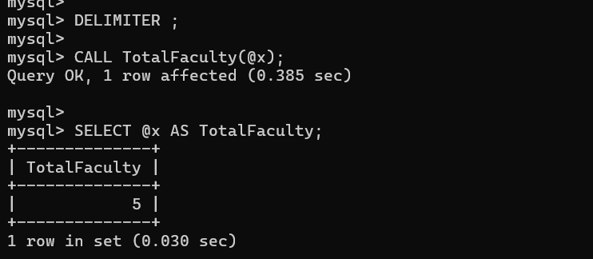

3. Procedure with IN and OUT

CREATE PROCEDURE AverageAge(
IN d VARCHAR(10),
OUT a DECIMAL(5,2)
)
BEGIN
SELECT AVG(Age) INTO a
FROM FACULTY
WHERE Dept = d;
END //
DELIMITER ;

CALL AverageAge('CSE', @avg);

SELECT @avg AS AverageAge;

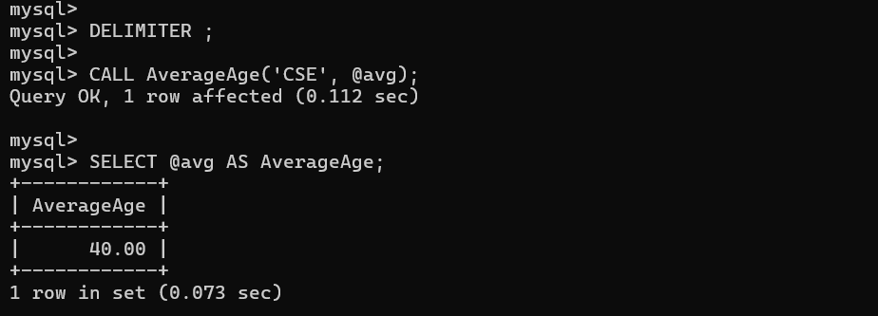

4. Procedure with INOUT Parameter

CREATE PROCEDURE DoubleNumber(INOUT n INT)
BEGIN
SET n = n * 2;
END //

DELIMITER ;

SET @x = 10;

CALL DoubleNumber(@x);

SELECT @x AS Result;
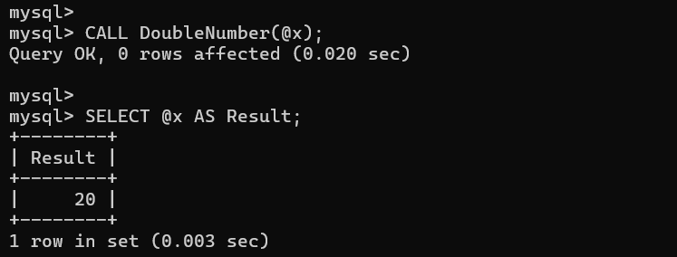

5. 5. Procedure using IF ELSE

CREATE PROCEDURE CheckAge(IN n INT)
BEGIN
IF n >= 18 THEN
SELECT 'Adult' AS Result;
ELSE
SELECT 'Minor' AS Result;
END IF;
END //

DELIMITER ;

CALL CheckAge(20);
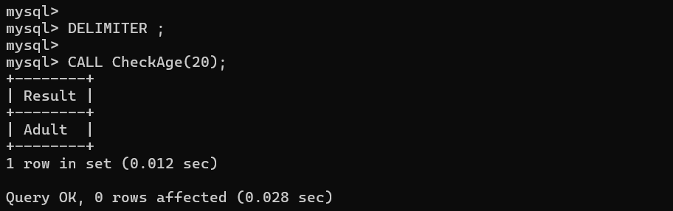

6. Procedure using WHILE Loop
CREATE PROCEDURE PrintNumbers(IN n INT)
BEGIN
DECLARE i INT DEFAULT 1;

WHILE i <= n DO
SELECT i AS Number;
SET i = i + 1;
END WHILE;
END //
DELIMITER ;
CALL PrintNumbers(5)

